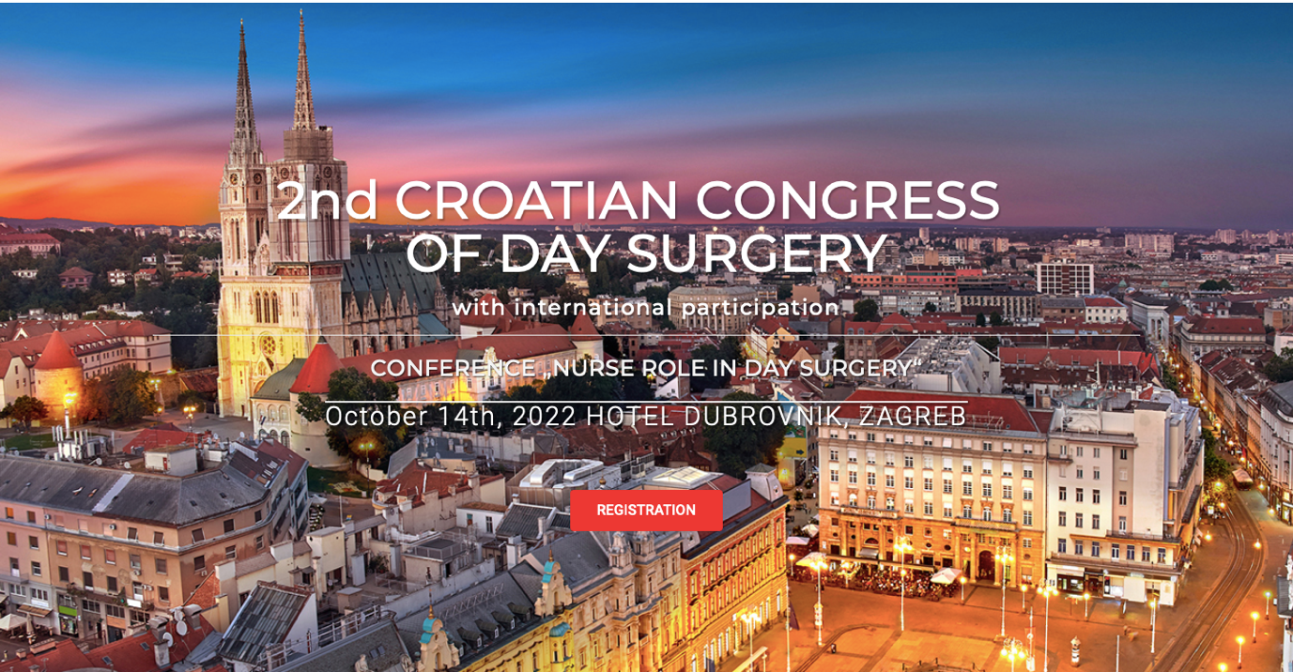

PROGRAMME

09:00-09:30 | Opening of the congress
 | Moderators: Ana Bosak Veršić, Filip Jurić
09:30-09:50 | What is one-day surgery?  Carlos Magalhaes, Portugal
09:55-10:10 | Day surgery in Croatia  Josip Baković, Croatia
10:15-10:30 | Dental procedures in children with general anesthesia  Elizabeta Gjorgievska, North Macedonia
10:35-10:50 | Day surgery at the Pediatric Surgery Department in Clinical Medical Center Rijeka  Branka Balaban, Marko Radman, Croatia
10:55-11:25 | Coffee break
 | MEDICAL DOCTORS SESSIONS
 | Moderators: Mario Knežević, Morana Milić
11:25-11:40 | Anesthesiological criteria for one-day surgery  Iva Smiljanić, Morena Milić, Croatia
11:45-11:55 | PIRS (percutaneous internal ring suturing technique) in day surgery  Ana Bosak Veršić, Croatia
11:55-12:05 | Day surgery in ENT  Dubravko Manestar, Croatia
12:05-12:20 | Emergency surgery in day surgery settings - back to the future  Filip Jurić, Croatia
12:20-12:35 | Selection of anesthesia in day surgery  Mario Nikolić, Morena Milić, Croatia
12:35-12:50 | Application of ProGrip meshes in the treatment of inguinal hernias  Radoslav Stipić, Croatia
12:50-13:05 | Bilateral thoracic paravertebral block at Th4-Th10 level under ultrasound control (OTPB) for laparoscopic cholecystectomy in one-day surgery, report of three cases  Ivo Jurišić, Croatia
13:05-13:20 | Postoperative pain and PONV in day surgery  Emanuel Borović, Croatia
13:20-13:35 | Current Croatian practice of preoperative testing in ambulatory surgery – are we ready for a different approach?  Gabrijela Bešlić, Hrvatska
13:35-13:45 | Discussion
13:45 -15:00 | Lunch break
14:15-15:00 | Croatian society for day surgery Assembly
 | Moderators: Robert Kliček, Iva Botica
15:00-15:15 | Interventional radiological procedures in day surgery  Antonio Bulum, Croatia
15:20-15:35 | Application of negative pressure therapy in day surgery  Robert Kliček, Croatia
15:40-15:55 | Effects of hospitalization on the child's socio-emotional development  Iva Kirša, Croatia
16:00-16:15 | Operative techniques in "office" hysteroscopy  Marko Klarić, Gabrijela Sopta Primorac, Croatia
16:20-16:35 | We agree there is no agreement – intragastric balloon placement and anesthesia  Ana Brundula, Croatia
16:40-17:10 | Coffee break
 | Moderators: Ana Bosak Veršić, Josip Baković
17:10-17:25 | Analgesia in pediatric day surgery  Vera Tulić, Croatia
17:30- 17:45 | Unplanned admission after the procedure in day surgery  Mario Knežević, Croatia
17:50-18:05 | Laparoscopic cholecystectomy in day surgery  Đana Vanjak Bielen, Croatia
18:10-18:25 | Adenotomy and tonsillectomy in day surgery  Iva Botica, Croatia
18:30-18:45 | Laser treatment of perianal fistulas  Ivan Romić, Croatia
18:45-18:55 | Day case surgery during Covid-19 pandemic  Ivan Silvije Gržan, Hrvatska
18:55-19:05 | Day surgery at University Hospital Mostar  Vlatka Martinović, Bosna i Hercegovina
19:05 | Closing of the congress
HOSPITAL DENTAL MEDICINE:
INTEGRATED APPROACH TO CONSERVATIVE AND
ORAL SURGICAL TREATMENT

Day oral surgery and dental rehabilitation under general anesthesia
Dental procedures under general anesthesia: indications and contraindications

Introduction:  11:25 | Prof. Željko Verzak, DMD, PhD “The first five years of the Day Hospital with day oral surgery at the Dental Clinic of University Hospital Center Zagreb”
 | Moderator: Prof.Irina Filipović Zore, DMD, PhD
11:40-11:55 | Prof. Vlaho Brailo, DMD, PhD “The structure of patients and the outcome of the triage process for dental rehabilitation under general anesthesia"
11:55-12:10 | Marin Lozić, MD, PhD “Dental procedures under general anesthesia: our protocol"
12:10-12:25 | Prof. Dragana Gabrić, DMD, PhD “Primary adenocarcinoma of the mandible - report of a rare case"
12:25-12:40 | Marko Vuletić, DMD, PhD " Ameloblastoma - enucleation or resection "
12:40-12:55 | Igor Blivajs, MD, PhD” Possibilities and limitations of surgery of the oral cavity and pharynx within the scope of day surgery"
12:55-13:10 | Assist.prof. Petar Đanić, DMD, PhD “Dental rehabilitation under general anesthesia - necessity or luxury"
13:10-13:45 | Discussion
13:45-15:00 | Lunch break
14:15-15:00 | Croatian society for day surgery assembly
All possibilities of dental treatment for children with developmental disabilities
Various specialties activities in the treatment of medically compromised patients
Systemic diseases - oral manifestations

 | Moderator: Marko Vuletić, DMD, PhD
15:00-15:15 | Assist.prof. Valentina Brzović Rajić, DMD, PhD “Endodontic treatment under general anesthesia: opportunities and challenges"
15:15-15:30 | Prof. Vlatko Pandurić, DMD, PhD “What can we do wrong during a one-visit endodontic treatment"
15:30-15:45 | Prof. Danica Vidović Juras, DMD, PhD “Hospital dental medicine - teamwork as the key to success"
15:45-16:00 | Assist.prof. Domagoj Vražić, DMD, PhD " Treatment of peri-implant diseases in hospital dental medicine - an insurmountable challenge?"
16:00-16:15 | Prof. Kristina Goršeta, DMD, PhD " Etiology and therapy of Molar-incisive hypomineralization"
16:15-16:30 | Prof. Tomislav Škrinjarić, DMD, PhD “Psychological preparation of pediatric oncology patients for dental treatment"
16:30-16:40 | Discussion
16:40-17:10 | Coffee break
 | Moderator: Prof. Ivana Medvedec Mikić, DMD, PhD
17:10-17:25 | Prof. Ivana Medvedec Mikić, DMD, PhD “Rehabilitation of hard dental tissues under endotracheal anesthesia in patients with ectodermal dysplasia - case report"
17:25-17:40 | Prof. Antonija Tadin, DMD, PhD “The quality of life of patients with special needs regarding their oral condition"
17:40-17:55 | Prof. Danko Bakarčić, DMD, PhD “Procedure of dental rehabilitation under general anesthesia in Clinical Hospital Center Rijeka”
17:55-18:10 | Prof. Nataša Ivančić Jokić, DMD, PhD “Results of 5 year practice of dental rehabilitation under general anesthesia in Clinical Hospital Center Rijeka“
18:10-18:30 | Discussion

